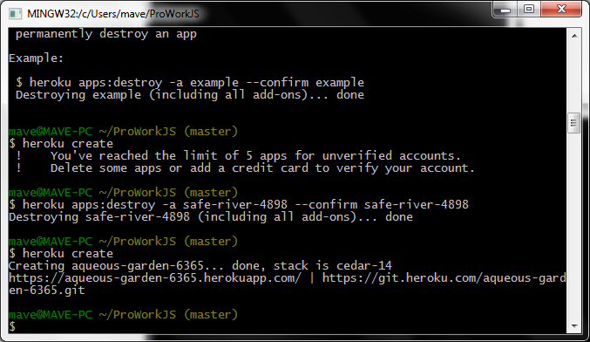

Want to destroy app: safe-river-4898

$heroku apps:destroy –a safe-river4898 –confirm safe-river-4898